COMP2113 Programming Technologies

ENGG1340 Computer Programming II

**Module 2 Checkpoint Exercise**

Name: YUAN Wenxuan

University ID: 3036292740

**Instructions:**

For each single question or each group of questions in the Checkpoint exercise, please type your answer right after the question in this Word document. Please refer to the example below.

Checkpoint 0:

What is the meaning of the command “date”?

Ans: The “date” command prints the current date of the current machine

**Checkpoint 2.1 (Please answer in this document and submit to Moodle)**

What is the output of the following shell script? Please explain your answer.

|  |
| --- |
| #!/bin/bash  a=100  b=99  if [ $a \> $b ]  then  echo "$a is larger"  else  echo "$b is larger"  fi  if [ $a -gt $b ]  then  echo "$a is larger"  else  echo "$b is larger"  fi |

Note: If you are using your own Linux, you may need to grant execute permission to run it.

Ans: The output is “99 is larger” in the first line and “100 is larger” in the second line. The first part compares “100” and “99” in the form of a string, and “100” is sorted before “99”, thus “99 is larger”. The second part compares 100 and 99 in the form of numbers.

**Checkpoint 2.2: Shell Script to mark all assignments (Please submit and evaluate your answer in VPL)**

Let’s upload the module files to the Linux server and browse to ~/Module2/Assignments/

|  |
| --- |
| $ cd ~/Module2/Assignments/  $ ls  2012111111 2012222222 2012333333 input.txt correct.txt mark.sh |

Let’s write a script to mark all the assignments in a class!

1. Suppose that the submission of each student is organized in the directory Assignments/UID, where UID is the University number of the student.
2. In this example we have three students with UID 2012111111, 2012222222 and 2012333333.
3. The test cases input.txt and correct.txt are located in the Assignments directory.
4. The shell script mark.sh is under the Assignments directory, to be updated by you.

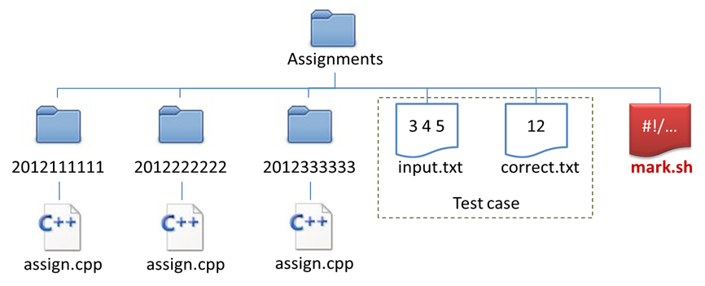

Consider the unfinished shell script *mark.sh*

|  |
| --- |
| #!/bin/bash  allStudents=**Q1**  for student in $allStudents  do  if **Q2**  then  cd $student  if **Q3**  then  g++ assign.cpp -o assign.o 2>error.txt  if **Q4**  then  ./assign.o < ../input.txt > output.txt  result=`diff output.txt ../correct.txt`  if **Q5**  then  echo "$student: Wrong answer."  else  echo "$student: Correct!"  fi  else  echo "$student: Cannot be compiled."  fi  fi  cd ..  fi  done |

Question1:

* What should be the code in Q1? (Reminder, spacing is critical!)
* Hints : First we need to get the names of the files and directories under our current directory, what is the command to do this? How we can execute shell command in shell script and store the result in the variable allStudents?

Question 2:

* However, the command in Q1 also returns files under the Assignments directory, such as the test case files *input.txt* and *correct.txt*, as well as the shell script *mark.sh*.
* We need an if statement, what should be the condition in Q2?
* Hints: How can we check if $student is a directory?

Question 3:

* After we have identified the student’s directories and browse into them one by one using the cd $student command, we need to check if the student has submitted *assign.cpp* or not.
* What is the condition to be filled in Q3?

Question 4:

* If the student has submitted *assign.cpp*, we then need to compile the *assign.cpp*, and report on screen if it cannot be compiled.
* We need to check if *assign.cpp* can be compiled or not.
* What is the condition to be filled in Q4?
* Hints: if the compilation is successful, what file will be created after executing the line

g++ assign.cpp -o assign.o 2> error.txt ?

Question 5:

* If the student has submitted *assign.cpp*, and *assign.cpp* can be compiled, we then need to check if the output file *output.txt* is the same as the test case correct.txt or not.
* The result=`diff output.txt ../correct.txt` command will store some value in the variable $result if *output.txt* is different from *correct.txt*.
* Therefore, if the length of the string $result is NOT EQUAL to 0, then there is something output by the diff command, that means *assign.o* returns wrong answer.
* What is the condition to be filled in Q5?

Upload your answer to the Moodle page “**Checkpoint 2.2:** **Shell Script to mark all assignments**” under Module 2 and **evaluate** it.

Please refer to “**Quick VPL Guide**” on Moodle if you are new to VPL.

**Checkpoint 2.3: Shell Script to analyze web log (Please submit and evaluate your answer in VPL)**

Suppose the web server of your company website that produces a log file which captures every page access in the following format:

*ip_address date_YYYY/mm/dd time_HH:MM:SS page_accessed*

Here is a sample content of such file:

|  |
| --- |
| 192.168.83.173 2014-09-04 10:05:17 /products.html  192.168.130.175 2014-09-04 10:09:13 /products/296.html  192.168.130.175 2014-09-04 10:25:01 /index.html  192.168.138.244 2014-09-04 10:29:37 /products.html  ... |

You are asked to write a shell script, **getProductAccess.sh**, which captures the product pages under **/products/** accessed by each IP address. The script takes one command line argument, which is the filename of a log file. It will read the content of the log file specified, find and print the product pages each IP address accessed. The output should be sorted by IP address and then by the product page.

* Sorting is done **alphabetically, ascendingly** for both IP address and product page, i.e., 192.168.0.**1**1 will be ordered before 192.168.0.**2**.
* Only pages starting with **/products/** should be printed.
* You can assume that the input file will strictly follow the above format. I.e.:
  + Each page access is recorded on a separated line.
  + Each value (*ip_address*, *date*, *time* and *page_accessed*) are separated by tabs.
  + The values will not consist of spaces or tabs.
* The script does not need to handle cases where the input file is empty, or if there is not enough argument specified.

**Sample Run**

Assume we have *access-2014-09-04.log* in the current directory, with the following content:

|  |
| --- |
| 192.168.83.173 2014-09-04 10:05:17 /products.html  192.168.130.175 2014-09-04 10:09:13 /products/296.html  192.168.130.175 2014-09-04 10:25:01 /index.html  192.168.138.244 2014-09-04 10:29:37 /products.html  192.168.83.173 2014-09-04 11:00:00 /products/004.html  192.168.130.175 2014-09-04 11:01:20 /products/296.html  192.168.138.244 2014-09-04 11:22:49 /products.html  192.168.138.244 2014-09-04 11:23:00 /index.html  192.168.83.173 2014-09-04 12:19:55 /products/560.html  192.168.130.175 2014-09-04 12:24:24 /products/004.html |

If we run the script like this:

|  |
| --- |
| $ ./getProductAccess.sh access-2014-09-04.log |

The script will print:

|  |
| --- |
| 192.168.130.175 /products/004.html  192.168.130.175 /products/296.html  192.168.83.173 /products/004.html  192.168.83.173 /products/560.html |

Note that IP 192.168.130.175 accessed /products/296.html multiple times, but there should only be one corresponding line in the output.

**Hints:**

* You may need to use the commands “cut”, “grep”, “sort” and/or “uniq” in your script.

Upload your answer to the Moodle page “**Checkpoint 2.3: Shell Script to analyze web**” under Module 2 and **evaluate** it.

**Checkpoint 2.4**

GitHub has an education plan to allow university students to apply for a professional account for free for at least two years. All students can join at <https://education.github.com/>.

Later for student projects, we plan to request students to commit their code and changes to GitHub mandatorily.

To apply for the professional account, you must:

1. Prepare a digital copy of your Student ID card.
2. Create a free GitHub account at <https://github.com/>.
3. Join the “GitHub Education” at <https://education.github.com/>.

Here are some steps to join the GitHub Education:

1. Specify you are a **student** and creating an **individual account**. Then click “Next”.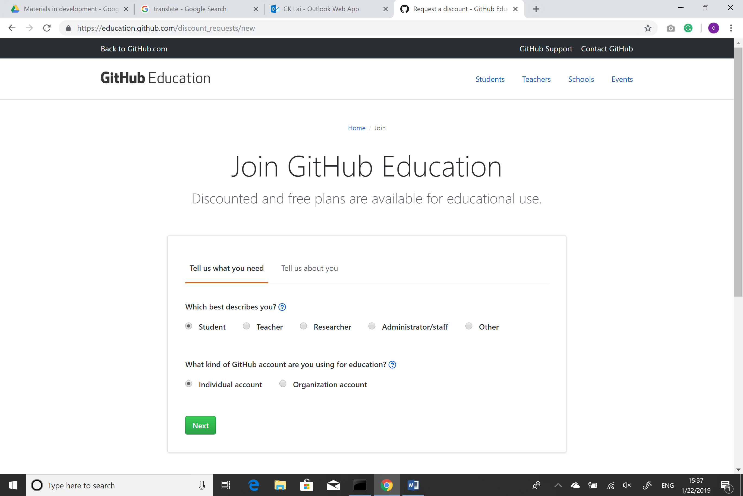
2. Add your HKU email address and then click “add”. A verification email will be sent to your HKU mailbox. Click the link in the email to verify it. After that, refresh the current page and upload the photo of your student ID card to the space provided. Then click “Submit request” 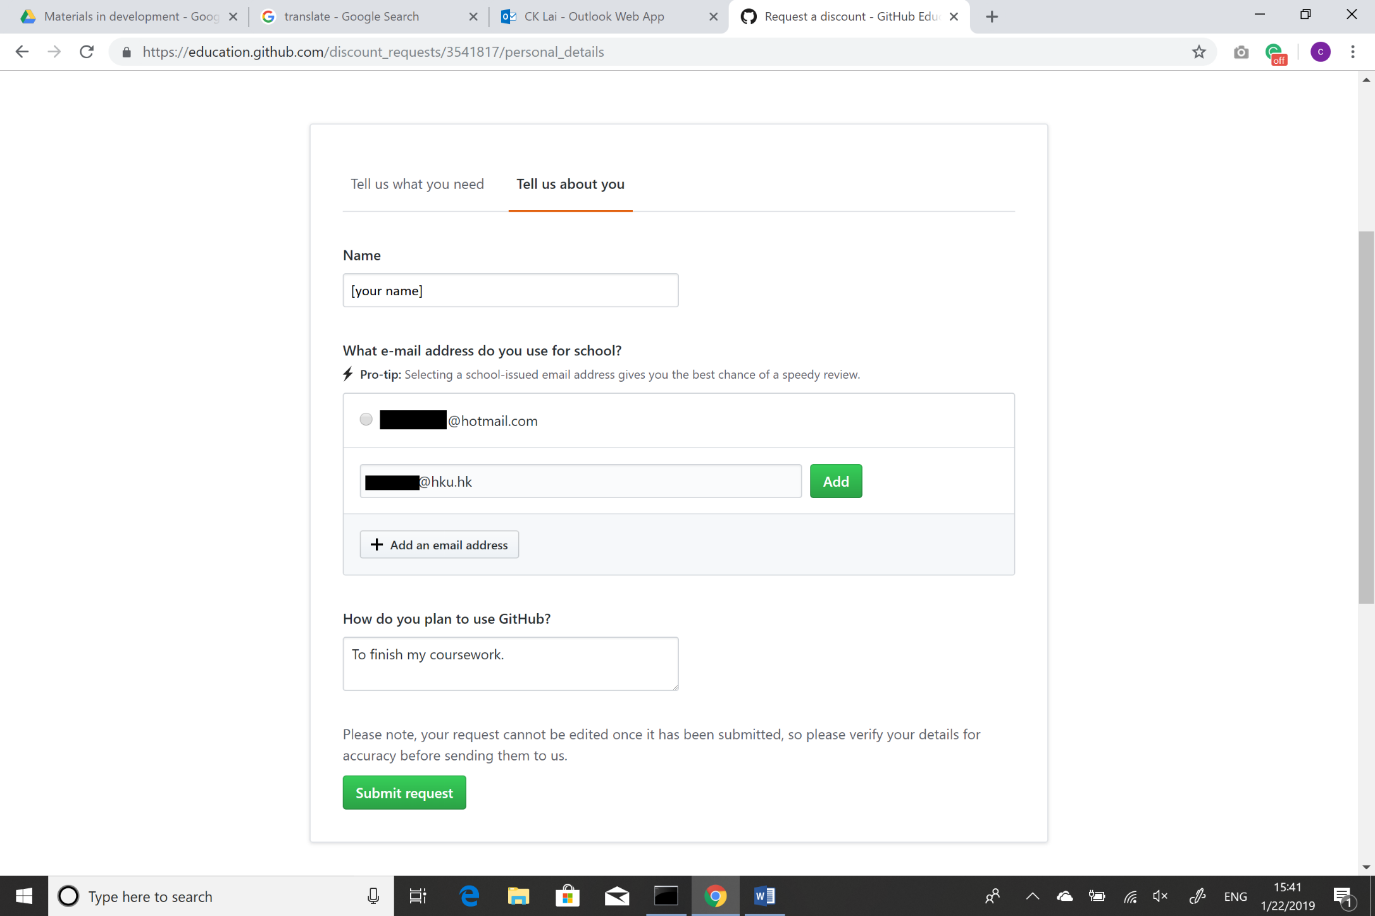
3. You will be notified your application result within 5 days 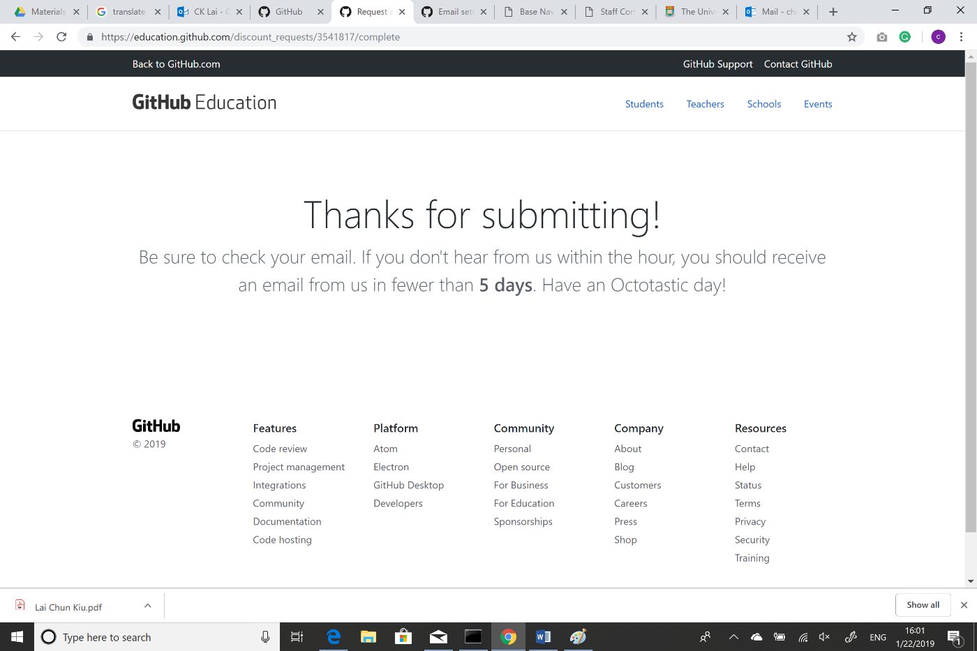

**Note: There is no need to submit anything for this checkpoint.**